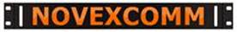 12 Volt DC LED BARS

Wiring information:
Positive Lead (Red)
Negative Lead (Black)

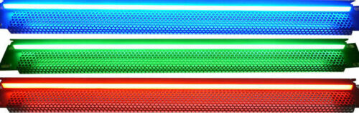

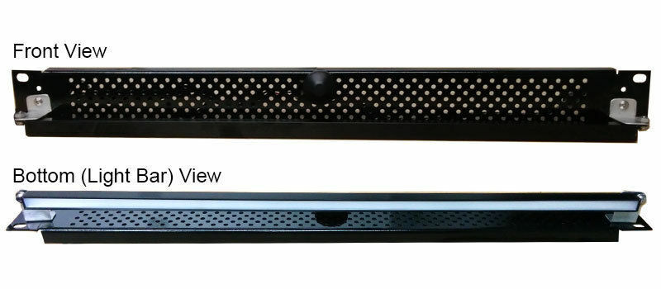

Thank you for purchasing one of our 12Volt DC LED Bars if you have any questions
Please contact us (310) 534-4456

Feel free to visit our website to see what other products we carry.
www.novexcomm.com visit the Products Tab and also visit Gallery Tab

